# Hierarchy Parser (Multi file source)

Hierarchy Parser is used to read hierarchical data ( from JSON, XML) into a relational format.

So, if my source is a JSON file and I want the data to be written as a csv file or to a database table, Hierarchy Parser is used.

Hierarchical Schema – the structure of the file that the Hierarchy Parser uses to convert the incoming hierarchical data into a relational output. The input passed to the Hierarchical Parser and the Hierarchical Schema has to match for the data to be converted as expected.

Hierarchical Schema

Login to Data Integration -> Components -> Hierarchical Schema

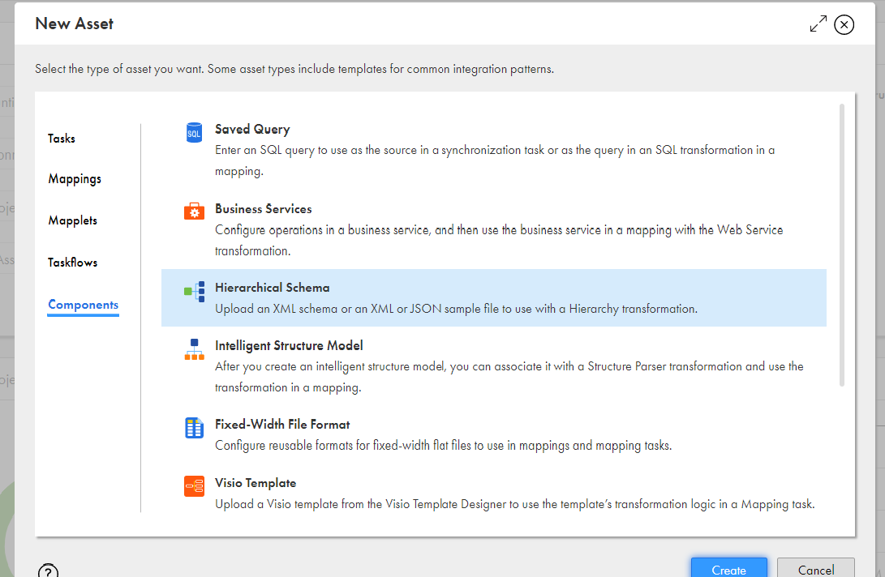

Example:

I have 2 JSON files, which has the details of Authors with the template:

[{

"AUTHOR_UID": 999,

"FIRST_NAME": "XXXXXX",

"MIDDLE_NAME": "XXXXX",

"LAST_NAME": "XXXXXX"

}]

I want to load both these JSON files to a target (Oracle table), which is created at the runtime.

So, first the Hierarchical schema has to be created. Goto the Hierarchical Schema, select the JSON template file, validate.



Now, I create a mapping with a Hierarchy Parse and map it to the schema template that is created.

Source: The multiple JSON files cannot be directly given as a source. A text file with the source filenames and the path is created to be used as a source.

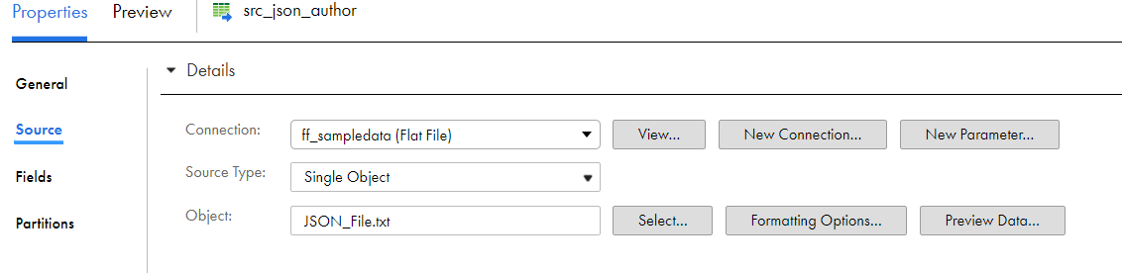

The schema template is mapped to the Hierarchy Parser. This has the format in which we want the output.

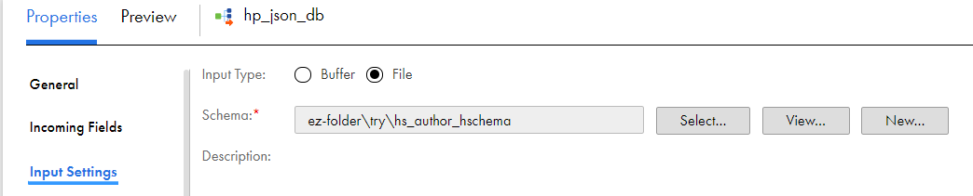

Target: The details from the multiple JSON files are written to the target- a dynamically created table in the Oracle database.

